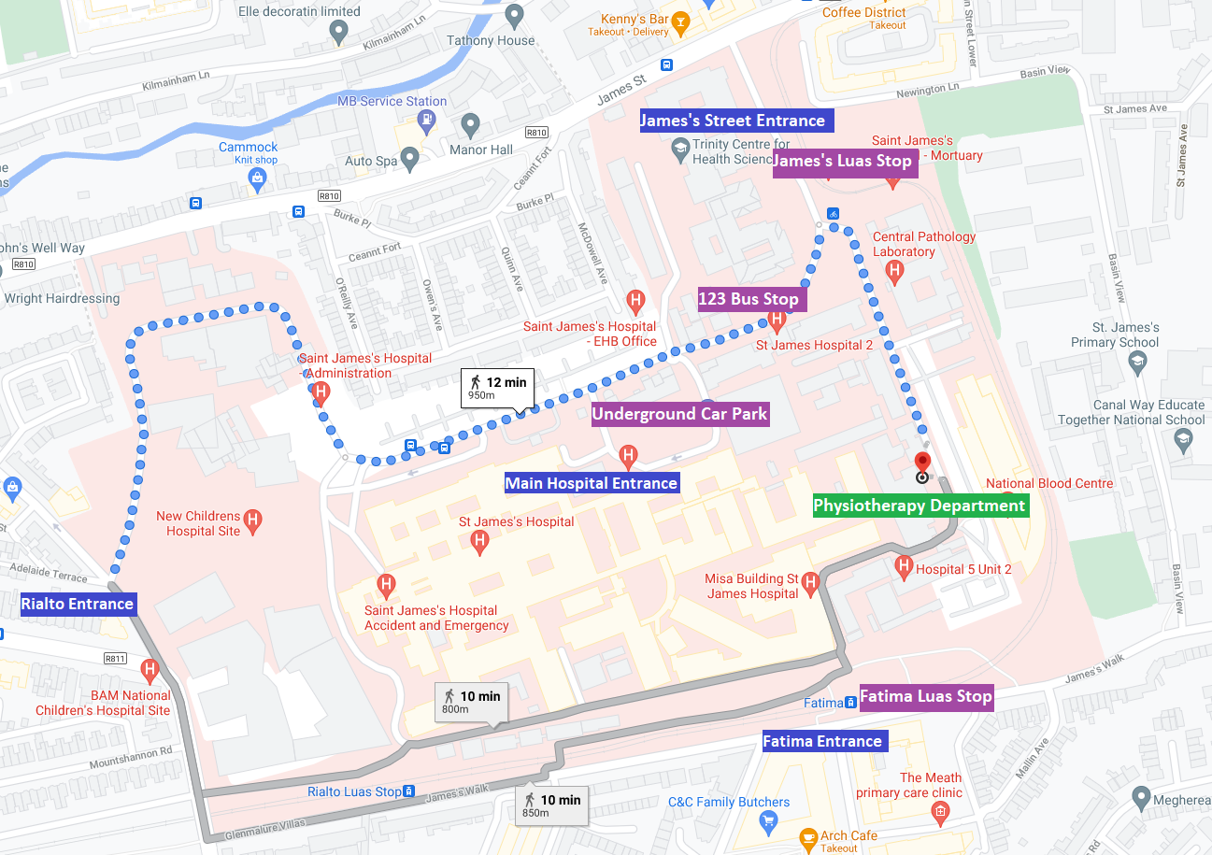
WHAT TO EXPECT
- The Physiotherapist will assess your movement including your flexibility, strength, muscle tone, balance and walking.
- Based on your assessment findings you will be given an exercise programme to work on at home.
- You will be given advice about managing your specific symptoms and about improving your general fitness.
- You will usually be reviewed for 4 to 6 sessions per episode, depending on your needs.
- You may be invited to participate in group exercise sessions.
- You have the option of a video or phone consult if it is difficult to attend the department in person.
- Your physiotherapist may link with your local community physiotherapist to help manage your condition and provide specific assessment in the home.

ABOUT YOUR APPOINTMENT
- Please attend all appointments on time as all patients are seen on a scheduled basis. It may not be possible to accommodate late attendances.
- Your physiotherapy appointment will generally last for 45-60 minutes.
- If you wear reading glasses, please bring these with you as you may be asked to complete a questionnaire at your first appointment.
- Please make sure to check in at the reception desk for all visits.
- It is recommended to wear loose comfortable clothing and runners.

OUR POLICIES
- If you cancel an appointment or fail to attend for any appointment when your course of treatment is underway, you must contact us for a new appointment within two weeks or you will be discharged.
- Please bring a list of any medications you take with you on your first visit.

PUBLIC TRANSPORT
- The 123 bus passes through the hospital grounds, stopping near the main concourse entrance.
- The 19 bus stops on the South Circular Road close to the Rialto entrance.
- There is a Luas stop in the hospital grounds near the James’ Street entrance. There is also a Luas stop at Fatima, which is a five-minute walk through the back of the hospital to the Physiotherapy Department.

CAR PARKING
- There is an underground car park near the Main Concourse that provides parking for patients and visitors. Surface parking is also available along the front aspect of the hospital near the ambulance bay, between junctions 3 and 4.
- There is a set-down area outside the Physiotherapy Department and two accessibility parking spaces. There is no other designated parking for the Physiotherapy Department.

PHYSIOTHERAPY DEPARTMENT
INFORMATION LEAFLET
Phone: 01-4162503 or 01-4162504
Email: physioreception@stjames.ie
If you are unable to attend, please contact us at the above number or email address at least 24 hours in advance.
You may be sent a text message as a reminder of your appointment.
Opening hours: 08:00-16:30, Monday-Friday
If you have any special needs as a result of a disability, please contact our Access Officer on 01-4284773.
We welcome your comments or suggestions for improvements, please fill in our comment card.
In the event of complaints, please contact the Physiotherapy Manager, Yvonne Burke, at YBurke@stjames.ie or 01-4162486, or the Complaints Officer at patientfeedback@stjames.ie or 01-4103361.

